Full Paper Title in Title Case (Font: Times New Roman 18 bold)

ABSTRACT
Use this template for preparing your submission for the symposium. The proceedings of the symposium will be published in an electronic format made available on the TEAAS website and indexed on Google Scholar. Your submission must adhere to the this template format or it will not be reviewed. You must submit in an MS-Word format. The abstract must not exceed 300 words and should appear on the top of the first page, after the title of the paper in the section titled "Abstract" after the names of the authors and the contact information of the corresponding author.

Keywords: Keyword1; Keyword 2; …..(Maximum 5 Keywords).

1. INTRODUCTION
Authors will submit carefully written and proofread material. The symposium language is English and papers are to be preared in American English. Spelling and grammatical errors, as well as language usage problems, are not acceptable in the final submission. There is no strict limitation to the number of pages, but the paper length must not exceed 1250 words. (exclusive of figure captions and references)
Papers should clearly describe and articulate the research background, the research methods used and results, and conclude with a discussion on the importance of the work and its contribution to advancing the practice of themed experiences and attractions. Papers are to be prepared in American English. Technical terms should be clearly explained. Acronyms should be written out at their first appearance.

2. SUBMITTING THE Paper
Submit your paper electronically through the XXXXXXXXX platform (http://submissionwebsite.com) the latest 31st of July 2026.

3. paper format
Utilizing the template helps accelerate the review process and subsequent compilation of the symposium proceedings. To aid in this, be sure to adhere to this template file in creating your submission. The template is provided to you in a US Letter format with .8 inch margins on all sides. Paragraphs should be single spaced, with the first line intended .5 inches (excepting the abstract). Double spacing should only be used before and after headings and subheadings as shown in this example. Position and style of headings and subheadings should follow this example. No spaces should be placed between paragraphs. Please do not change any of the page, paragraph and font settings.

3.1. Fonts
Papers should use 11-point Times New Roman font. The styles available are bold, italic, bold italic, and underlined. It is recommended that text in figures is not smaller than 10-point font size.

3.2. Tables and Figures
Figure captions and table headings should be sufficient to explain the figure or table without needing to refer to the text. Figures and tables not cited in the text should not be presented. Styles Heading Table and Caption Figure are available in this template for tables and figures. The following is the example for Table 1.
Table 1 Title of Example Table
 | Balance |  | Repetition |  | Rhythm
Park | Mean | SD | Mean | SD | Mean | SD
Tokyo DisneySea | 6.2 | 1.15 | 4.1 | .76 | 3.2 | .93
Disneyland | 4.4 | .82 | 6.7 | 1.55 | 5.5 | .88

Tables and figures should be placed near to their first reference in the text. All figures and tables should be numbered with Arabic numerals. All figures and tables must be referred to in the text. Table headings should be placed above the tables. Figure captions should be centred below the figures. Minimum figures’ resolution: 150dpi.

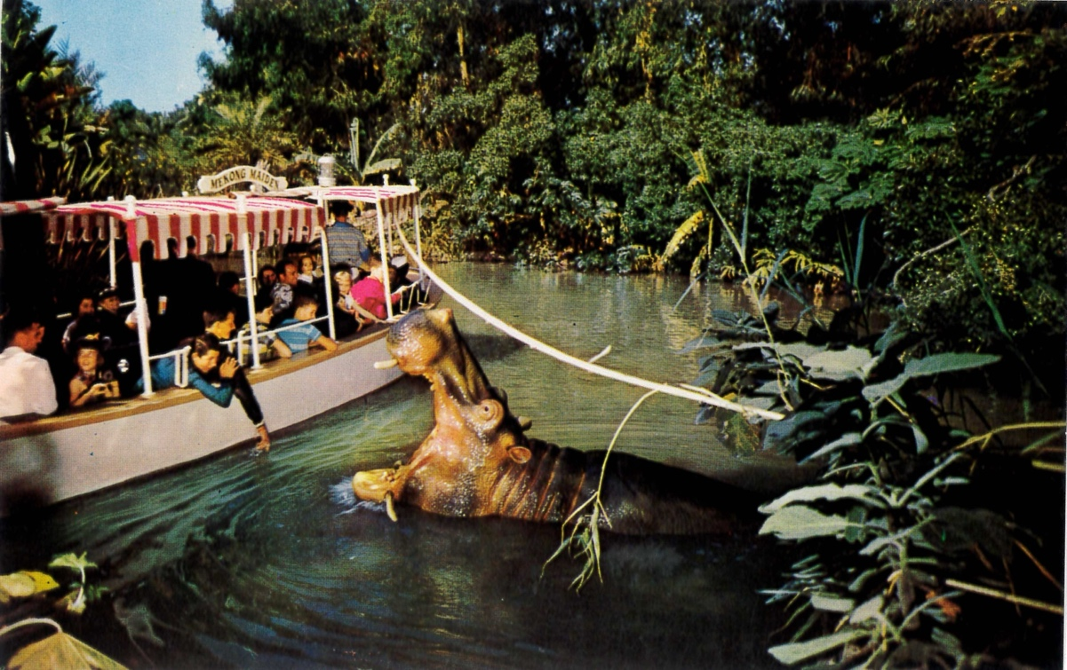
Figure 1: Captions should be no smaller than 10 point font and aligned center.

acknowledgements
List here the persons, organisations etc. you would like to acknowledge if applicable. Do not indent acknowledgments.

REFERENCES
List of references must follow APA style.
For more information, please visit: http://www.apastyle.org/index.aspx

